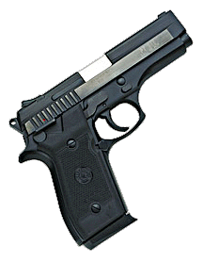
Taurus PT-945
Ammo | Mag | Rng | ROF | Dam | Arm
.45 ACP | 8 | 10 | 2 | 2 | x3
Taurus PT-945: Taurus does again what it does best. A perfect home / personal defense weapon. The PT-945 is a .45 ACP version of the home owner favorite 911. Though not made for combat action, many civilians lost, sold, or involuntarily gave up their personal defense weapons. Thus, many Taurus products have made their way into military hands throughout the war. Nation: United States Weight: .95 kg
Ammunition: .45 ACP Magazine: 8
Price: $484 Availability: ( S/R )

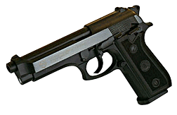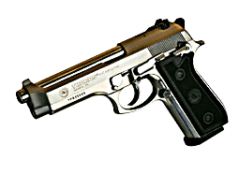
Taurus PT-92 / 99
Ammo | Mag | Rng | ROF | Dam | Arm
9mm P | 15 | 15 | 2 | 1 | x2
Taurus PT-92 / 99: Taurus’ version of the ever popular Beretta 92. This handgun has been used mainly for personal defense, but many have crept their way into law enforcement and military units.
Nation: United States Weight: .95 kg
Ammunition: 9mm P Magazine: 15
Price: $425 Availability: ( C/S )

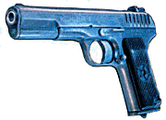
Tokarev
Ammo | Mag | Rng | ROF | Dam | Arm
7.62T | 8 | 10 | 2 | 1 | x4
Tokarev: The Tokarev was the standard issue sidearm for the Soviet Union in WWII and is still in service with that army, as well as in the armies of other Warsaw Pact nations. It is notable for its similarity to the American .45 caliber service automatic, and for its lack of a safety catch.
Nation: USSR Weight: .5kg
Ammunition: 7.62mm T Magazine: 8
Price: $250 Availability: ( R/C )

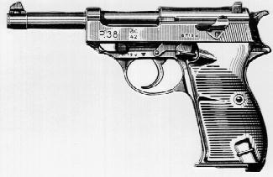
Walther P-38
Ammo | Mag | Rng | ROF | Dam | Arm
9mm P | 8 | 15 | 2 | 1 | x2
Walther P-38: The standard issue sidearm of the German Army in WW II, the P-38 was designed as a simpler, more rugged replacement for the Luger. It can still be found in many armies throughout the world.
Nation: Germany Weight: .77 kg
Ammunition: 9mm P Magazine: 8
Price: $824 Availability: ( C/R )

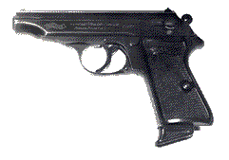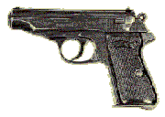
Walther PP
Ammo | Mag | Rng | ROF | Dam | Arm
.22 LR  .32 ACP  .380 ACP | 15  7  7 | 12  10  10 | 3  2  2 | 0  1  1 | x4  x4  x4
Walther PP: The Walther PP set the stage for it’s “younger brother,” the PPK. The Walther PP’s versatility, size and quality captured the interest of many people and organizations.
Nation: Germany Weight: .68 kg
Ammunition: .22 LR, .380, .32 Magazine: 15 / 10 / 10
Price: $999 Availability: ( S/R )

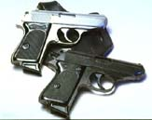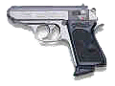
Walther PPK
Ammo | Mag | Rng | ROF | Dam | Arm
.32 ACP  .380 ACP | 6  6 | 10  10 | 2  2 | 1  1 | x4  x3
Walther PPK: A small automatic pistol best known as the preferred sidearm of fictional spy James Bond. In reality, it was used by the British Secret Service until it was replaced in the mid-1970s by the H&K VP-70z. The PPK/s version weighs .68 kg and has a 7 round capacity magazine.
Nation: Germany Weight: .65 kg
Ammunition: .32 ACP / .380 Magazine: 6
Price: $650 Availability: ( S/R )

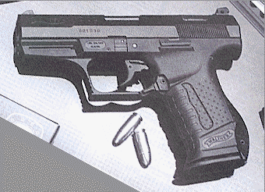
Walther P-99
Ammo | Mag | Rng | ROF | Dam | Arm
9mm P | 16 | 17 | 2 | 1 | x2
Walther P-99: The P-99, AKA the “New Bond Gun,” is a compilation of quality and necessity. The PP and PPK have made a reputation for unmatchable quality Walther’s obsession. The new P-99 is a high capacity, double action 9mm, made of High Tech Polymers and Quality Metals. One word describes the weapon perfectly: Walther.
Nation: Germany Weight: .90 kg
Ammunition: 9mm P Magazine: 16
Price: $800 Availability: ( R/R )

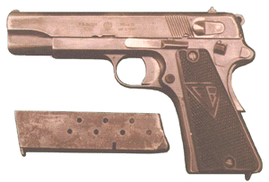
Vis wz. 35
Ammo | Mag | Rng | ROF | Dam | Arm
9mm P | 8 | 15 | 2 | 1 | x2
Vis wz. 35: Vis is a recoil operated, single-action pistol. Externally it closely resembles Colt 1911 but it's not a copy. It uses a cam-lug system of operation similar to that of Browning Hi-Power.
Nation: Poland Weight: 1.02 kg
Ammunition: 9mm P Magazine: 8
Price: $250 Availability: ( -/S )

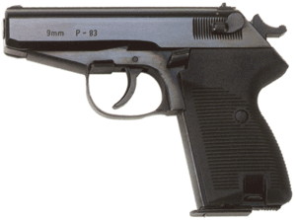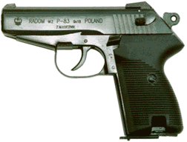
P-83 Wanad
Ammo | Mag | Rng | ROF | Dam | Arm
9mm M | 8 | 15 | 2 | 1 | x4
Radom P-83 Wanad: P-83 is a blowback operated double-action pistol. The frame and slide are made mostly of sheet steel stampings. Barrel is pined to the frame. It replaced the P-64 as the standard sidearm for Poland
Nation: Poland Weight: .73 kg
Ammunition: 9mm M Magazine: 8
Price: $350 Availability: ( R/C )

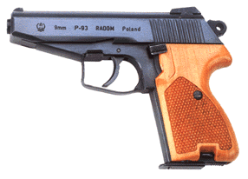
P-93
Ammo | Mag | Rng | ROF | Dam | Arm
9mm M | 8 | 15 | 2 | 1 | x4
P-93: The P-93 was introduced as a substitute for the P-83, however was soon after rejected by the Polish military. The P-93 has become popular, despite it’s early rejection, and found it’s way into the hands of Police Officers and Citizens.
Nation: Poland Weight: .75 kg
Ammunition: 9mm M Magazine: 8
Price: $380 Availability: ( R/C )

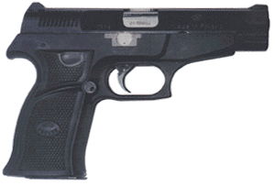
WIST 94
Ammo | Mag | Rng | ROF | Dam | Arm
9mm P | 16 | 15 | 2 | 1 | x2
WIST 94: Prexer, learning from P-93’s errs, made the WIST 94 as a possible substitute for the P-83 as a standard sidearm for the Polish Military. It featured a high capacity magazine the the widely used 9mm P round for ammunition, instead of the less common 9mm M. This weapon was accepted and is currently in use by the Polish Military.
Nation: Poland Weight: .77 kg
Ammunition: 9mm P Magazine: 16
Price: $520 Availability: ( S/C )

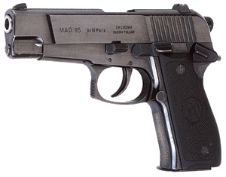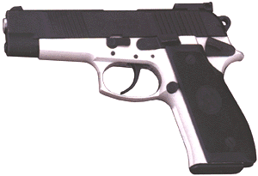
MAG 95 / 98
Ammo | Mag | Rng | ROF | Dam | Arm
9mm P | 15 / 20 | 15 | 2 | 1 | x2
MAG 95 / 98: MAG 95 is a pretty conventional high-capacity, double-action 9mm Parabellum pistol. It operates on the short recoil, locked breech principle. The rear or the barrel ends in a squared-off block that locks the barrel to the slide's enlarged ejection port. The frame is made of either steel (MAG 95) or light alloy (MAG 98)
Nation: Poland Weight: 1.1 kg / .87 kg
Ammunition: 9mm P Magazine: 15 / 20
Price: $500 / $680 Availability: ( R/S )

